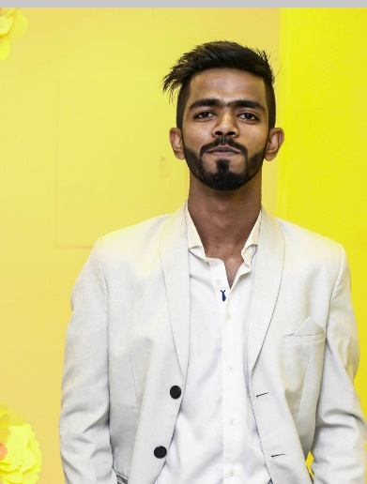

**MD. JAWAD BIN YOUSUF**

 : 01855079901,  : [binyousufjawad@gmail.com](mailto:binyousufjawad@gmail.com)  : Ga-94, Mohakhali, Dhaka, Dhaka, Bangladesh.

Birth Date: 08/25/1998 Gender: Male

Marital Status: Single

Nationality: Bangladesh

# **SUMMARY**

Worked hard in the past to learn new processes, improve procedures, and improve customer satisfaction. Multitasking and organizational skills are strengths of this talented leader, communicator and conflict manager. Excellent planning, organizing and communication abilities.

**EMPLOYMENT HISTORY**

Sales Specialist – ROBI February 2016 - December 2016

Chittagong, Bangladesh

* Made sure that the team’s actions were in line with company policies and industry standards.
* Planned and implanted team projects to meet objectives.
* Explained services and products to customers in a friendly and engaging manager.
* Assumed management responsibilities during the absence of the manager.

# Campus Ambassador - BRITISH EDUCARE March 2021 – September 2021

Dhaka, Bangladesh

* Explained services and products to customers in a friendly and engaging manner.
* Regulated service delivery in order to keep operations efficient and within budget.

# Campus Ambassador – KALKE September 2021 - Till Date

Dhaka, Bangladesh

* Assisted the team in the “Performance Improvement” department with various projects involving market entry strategies and options design, market assessment and industry studies.
* Established communication with people to reach our goals.

# **EDUCATION**

Govt. Muslim High School - Secondary School Certificate CGPA- 4.84 OUT OF 5

(Science)

Chittagong, Bangladesh. January 2007 - May 2013

# South Asian College - Higher Secondary Certificate CGPA- 3.5 OUT OF 5

(Science)

Chittagong, Bangladesh. January 2014 - May 2015

# East Delta University - Bachelor of Engineering CGPA- 3.71 OUT OF 4

(Computer Science)

Chittagong, Bangladesh. January 2016 - April 2018

# BRAC University - Bachelor of Engineering CGPA- 3.10 OUT OF 4

(Computer Science)

Dhaka, Bangladesh. May 2018 - October 2022

**SKILLS**

* Regulatory Affairs
* Customer Relationship Management
* Global Sales and Marketing
* Interpersonal Skills
* Customer Retention
* Employee Development
* Team Leadership
* Safety Protocol
* Workflow Planning
* Outsourcing

**ADDITIONAL INFORMATION**

* I was the lead volunteer and head HR for the convocation of BRAC University’19 where Our honorable president and honorable UN president was present.
* I worked for administration in BRAC University for two months.
* I did take survey of 2000 people which Corona symptoms they have.
* I have volunteer certificate of HULT Prize Event.
* I have certificate of Coursera where I completed courses about web programming.
* HTML, CSS and JAVASCRIPT for Web Developer
* SQL Databases
* Website with WORDPRESS.

**MAJOR SKILLS**

* I did courses on SQL Databases in Coursera and I am familiar with SQLite.
* I am experiencing PHP now. Php Laravel Framework included.
* I am learning web development also for 4 years. WordPress is added.
* I am learning and experienced with HTML, CSS AND JAVASCRIPT
* I am familiar with HR work.
* I have done course on HR and Economics.

**HOBBIES**

Reading, Field Games, Travelling, Workout

**SOCIAL LINKS**

LINKEDIN - <https://www.linkedin.com/in/jawad-bin-yousuf-1a1729165/>

GITHUB - <https://github.com/jawadbinyousuf>

FACEBOOK - <https://www.facebook.com/psychic.jawad/>

**REFEREES**

Dr. Jia Uddin, PhD,

Department of Computer Science and Engineering

Associate Professor,

BRAC University.

Mobile: +88-01817205771